Christopher Rei-Mohammed

Dr. Schwartz

Bio 539 Big Data Analysis

Final Project – Pigment Cell Analysis

8 May 2020

The goal of this research project is to determine the role of *alx4a* in the specification of iridophores from bipotent iridophore/melanophore precursors. By identifying the components involved in iridophore fate specification, I hope to better understand how the genes involved interact with each other to produce correctly differentiated cell types. Identifying the role of *alx4a* and *alx4b* during development may also lead to a better understanding of how these two copies of the *alx4* gene influenced the evolution of teleosts.

Based on preliminary results, *alx4a* homozygous mutants lack all iridophores and have increased numbers of melanophores. This suggests that *alx4a* plays a role in repressing *mitfa* during the fate specification of pigment cells, and in driving the iridophore fate. This project will incorporate molecular analyses, but this part is focused on observing the effects of mutations in the *alx4a* gene on pigment cell numbers during development. In particular, I want to examine different phenotypes and how their relative numbers of pigment cells are affected during development.

Iridophores are counted dorsally (starting at the posterior end of the operculum to the posterior end of the tail), and ventrally (starting at the posterior end of the yolk sac/swim bladder to posterior end of the tail. Melanophores are only counted dorsally, and they are counted the same way as dorsal melanophores. For imaging iridophores, the embryos are anesthetized using ~1-1.5mL Tricaine, then are transferred into 3% methylcellulose for imaging. The embryo can be manipulated using a microinjection needle loading pipet tip.

For imaging melanophores, the embryos are transferred into a Petri dish containing a small amount of epinephrine to contract the melanophores, then are transferred into a tricaine dish before being transferred into 3% methylcellulose. There is no exact amount of epinephrine to use and the melanophores will start to relax if embryos are left in tricaine for more than ~30s. In order to anesthetize fish faster, and give melanophores less time to relax, I will need to inquire about using ~2-2.25mL Tricaine, and see if it is safe for the fish and if it is a more effective method.

Despite the preliminary data numbers being rather small, due to difficulties in collecting enough embryos for analysis, analyzing the data in different ways using different methods can still offer valuable insight as to what one might expect to, or should look out for, as the data grows in size. RStudio is a good program for analyzing large datasets, but it can also be used with smaller datasets to setup a base code for analyzing the data. Then, as the amount of data collected increases, that base code can be adapted to work with the larger datasets. Furthermore, RStudio is a useful tool when it comes to filtering and organizing data in different ways, compared to a program like Excel. With RStudio I was able to generate multiple data tables and plots by simply filtering and plotting the data in slightly different ways. My data essentially consists of a single type of measurement, pigment cell counts, and limiting how I filter it. Yet, using that single type of measurement allowed me to look at the data in ways I had not previously considered. When working with the data in Excel, I had only ever analyzed it from the perspective of comparing the different phenotypes to each other within a single genetic line. I had never considered plotting the data for each phenotype separately, and combining the respective phenotype plots with the data from both genetic lines, which is best exemplified by Figures 1, 2, and 4.

Based on preliminary data there is a trend between *alx4a* mutants (4bp del, 8bp insert), and the numbers of melanophores and iridophores they possess. In Figure 1 and 2, nearly all mutant embryos lack iridophores entirely, both dorsally and ventrally. The few mutants that do possess iridophores have less than five total each. With the exception of a few outliers, the majority of mutants also possess more melanophores than their wild type siblings, which can be seen in Figure 3. By refining the filtered data in RStudio and changing how I plotted the data, I was able to find an interesting that I had not noticed before. While mutant fish usually have more melanophores than their wild type siblings, I also found that the 8bp insert fish tend to have more dorsal melanophores than the 4bp del fish across both phenotypes (Figure 4).

The attached data tables can be referenced for pigment cell counts, and the corresponding graphs display the number of iridophores/melanophores in mutant embryos relative to their wild type siblings. There are not melanophore/iridophore graphs for each mutant line (4bp del, 8bp insert) due to either low embryo survival or unsuccessful breeding. This prevents the data from being robust enough to draw conclusions from, but it does provide a trend to look for in future analyses. The observed trend can be used as an indicator of the type of relationship I can expect to see with larger sample sizes.

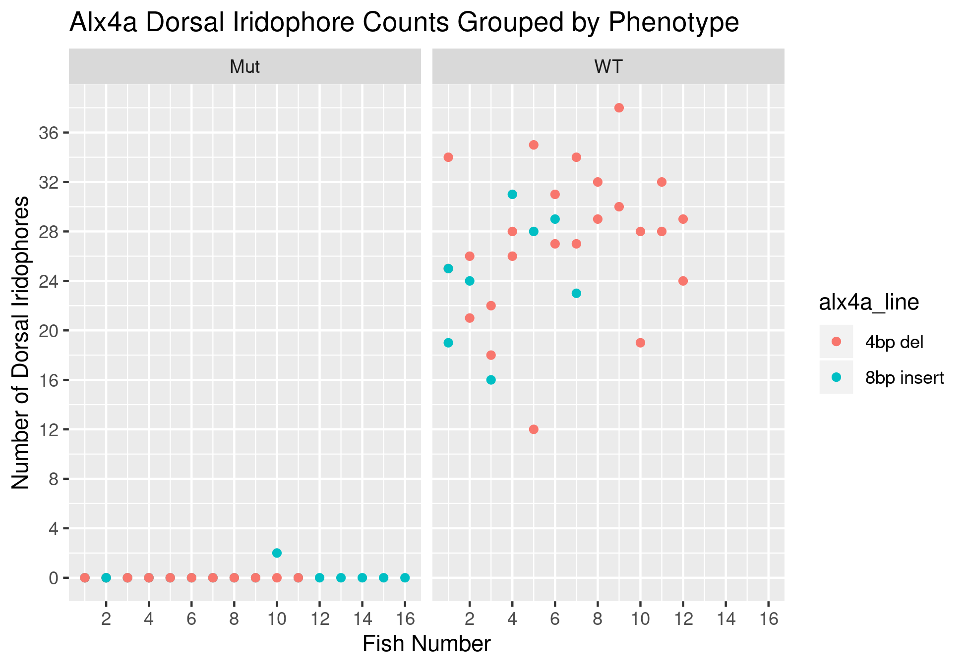

Figure 1. A pair of plots of the dorsal iridophore cell counts of two alx4a lines separated by phenotype. In homozygous mutant alx4a fish nearly all of the fish have zero dorsal iridophores, except for one outlier. While none of the wild type fish, across both genetic lines, have less than 12 dorsal iridophores. Based on what is known about the alx4a gene this is what one would expect to see in the mutant phenotype regardless of genetic line.

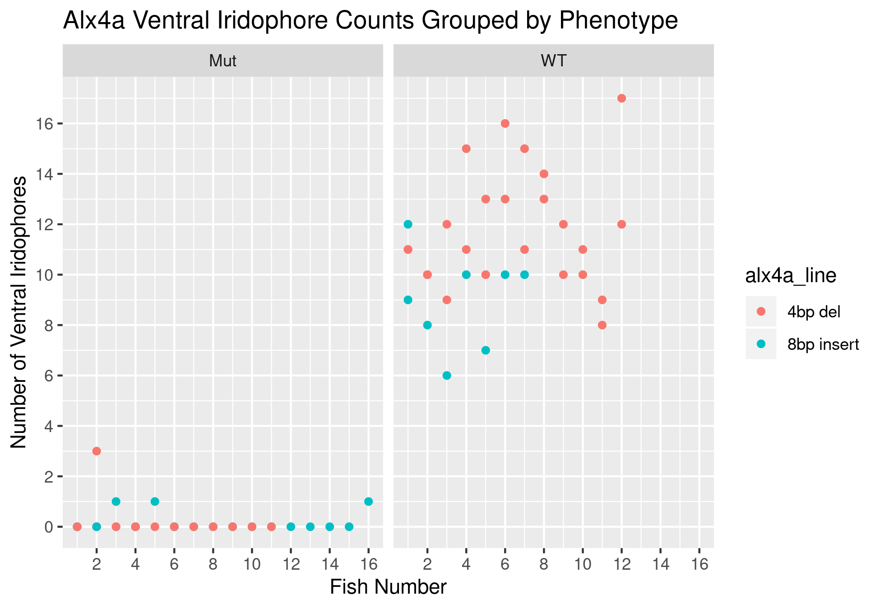

Figure 2. A pair of plots of the ventral iridophore cell counts of two alx4a lines separated by phenotype. Similar to the plots in Figure 1, the majority of mutant fish have zero ventral iridophores, with the exception of 4 outliers. This matches the expected observation of the mutant fish. None of the wild type fish have less than 6 ventral iridophores.

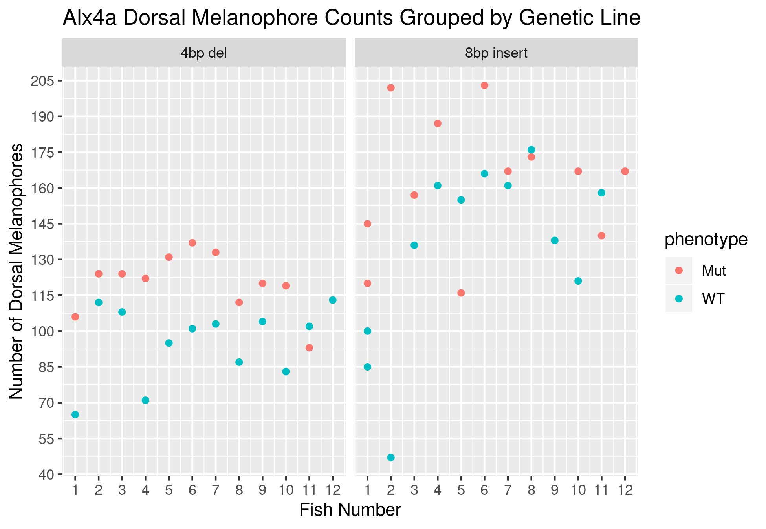

Figure 3. A pair of plots showing the dorsal melanophores cell counts for the distinct genetic lines, while plotting both mutant and wild type phenotypes on the same graph for each genetic line respectively. Across both genetic lines the general trend is that mutant fish have more melanophores than their wild type siblings. This is what we expect to see because mutant fish lack *alx4a*, a repressor of *mitfa*, resulting increased levels of *mitfa* during development which should result in increased levels of melanophores.

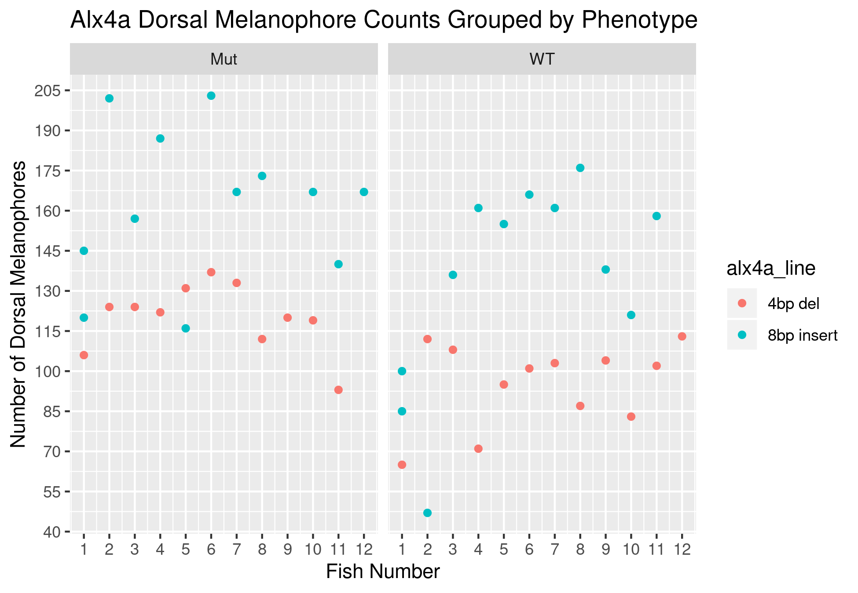

Figure 4. Plots, expanding on the trend seen in Figure 3, grouping the all data by phenotype allowing for comparisons to be made between the two genetic lines for the same phenotype. The trend that can be seen in the plots is that 8bp insert fish, regardless of phenotype, tend to have more dorsal iridophores than the 4bp del fish. This is a trend being observed in a small amount of data and nothing conclusive can be drawn from it yet. If the trend holds true as more data is collected, it might warrant further investigation as to why this difference exists.

|  |  |  |  |  |  |
| --- | --- | --- | --- | --- | --- |
| fish_number | alx4a_line | phenotype | pigment_cell_type | dorsal_cell_counts | date_melanophore |
| 1 | 8bp insert | WT | melanophores | 85 | 2019-09-19 |
| 2 | 8bp insert | WT | melanophores | 47 | 2019-09-19 |
| 3 | 8bp insert | WT | melanophores | 136 | 2019-09-19 |
| 4 | 8bp insert | WT | melanophores | 161 | 2019-09-19 |
| 5 | 8bp insert | WT | melanophores | 155 | 2019-09-19 |
| 6 | 8bp insert | WT | melanophores | 166 | 2019-09-19 |
| 7 | 8bp insert | WT | melanophores | 161 | 2019-09-19 |
| 8 | 8bp insert | WT | melanophores | 176 | 2019-09-19 |
| 9 | 8bp insert | WT | melanophores | 138 | 2019-09-19 |
| 10 | 8bp insert | WT | melanophores | 121 | 2019-09-19 |
| 11 | 8bp insert | WT | melanophores | 158 | 2019-09-19 |
| 1 | 8bp insert | Mut | melanophores | 145 | 2019-09-19 |
| 2 | 8bp insert | Mut | melanophores | 202 | 2019-09-19 |
| 3 | 8bp insert | Mut | melanophores | 157 | 2019-09-19 |
| 4 | 8bp insert | Mut | melanophores | 187 | 2019-09-19 |
| 5 | 8bp insert | Mut | melanophores | 116 | 2019-09-19 |
| 6 | 8bp insert | Mut | melanophores | 203 | 2019-09-19 |
| 7 | 8bp insert | Mut | melanophores | 167 | 2019-09-19 |
| 8 | 8bp insert | Mut | melanophores | 173 | 2019-09-19 |
| 10 | 8bp insert | Mut | melanophores | 167 | 2019-09-19 |
| 11 | 8bp insert | Mut | melanophores | 140 | 2019-09-19 |
| 12 | 8bp insert | Mut | melanophores | 167 | 2019-09-19 |
| 1 | 4bp del | WT | melanophores | 65 | 2019-10-23 |
| 2 | 4bp del | WT | melanophores | 112 | 2019-10-23 |
| 3 | 4bp del | WT | melanophores | 108 | 2019-10-23 |
| 4 | 4bp del | WT | melanophores | 71 | 2019-10-23 |
| 5 | 4bp del | WT | melanophores | 95 | 2019-10-23 |
| 6 | 4bp del | WT | melanophores | 101 | 2019-10-23 |
| 7 | 4bp del | WT | melanophores | 103 | 2019-10-23 |
| 8 | 4bp del | WT | melanophores | 87 | 2019-10-23 |
| 9 | 4bp del | WT | melanophores | 104 | 2019-10-23 |
| 10 | 4bp del | WT | melanophores | 83 | 2019-10-23 |
| 11 | 4bp del | WT | melanophores | 102 | 2019-10-23 |
| 12 | 4bp del | WT | melanophores | 113 | 2019-10-23 |
| 1 | 4bp del | Mut | melanophores | 106 | 2019-10-23 |
| 2 | 4bp del | Mut | melanophores | 124 | 2019-10-23 |
| 3 | 4bp del | Mut | melanophores | 124 | 2019-10-23 |
| 4 | 4bp del | Mut | melanophores | 122 | 2019-10-23 |
| 5 | 4bp del | Mut | melanophores | 131 | 2019-10-23 |
| 6 | 4bp del | Mut | melanophores | 137 | 2019-10-23 |
| 7 | 4bp del | Mut | melanophores | 133 | 2019-10-23 |
| 8 | 4bp del | Mut | melanophores | 112 | 2019-10-23 |
| 9 | 4bp del | Mut | melanophores | 120 | 2019-10-23 |
| 10 | 4bp del | Mut | melanophores | 119 | 2019-10-23 |
| 11 | 4bp del | Mut | melanophores | 93 | 2019-10-23 |
| 1 | 8bp insert | WT | melanophores | 100 | 2019-11-05 |
| 1 | 8bp insert | Mut | melanophores | 120 | 2019-11-05 |

Table 1. A data table containing all of the dorsal melanophore cell counts for both mutant and wild type fish across both genetic lines. The NA values were filtered out of this data table using RStudio. The raw data table will be available in the git repository where this document will be stored.

|  |  |  |  |  |  |  |
| --- | --- | --- | --- | --- | --- | --- |
| fish_number | alx4a_line | phenotype | pigment_cell_type | dorsal_cell_counts | ventral_cell_counts | date_iridophore |
| 1 | 4bp del | WT | iridophores | 34 | 11 | 2019-09-18 |
| 2 | 4bp del | WT | iridophores | 26 | 10 | 2019-09-18 |
| 3 | 4bp del | WT | iridophores | 22 | 12 | 2019-09-18 |
| 4 | 4bp del | WT | iridophores | 26 | 11 | 2019-09-18 |
| 5 | 4bp del | WT | iridophores | 35 | 13 | 2019-09-18 |
| 6 | 4bp del | WT | iridophores | 27 | 13 | 2019-09-18 |
| 7 | 4bp del | WT | iridophores | 34 | 11 | 2019-09-18 |
| 8 | 4bp del | WT | iridophores | 29 | 13 | 2019-09-18 |
| 9 | 4bp del | WT | iridophores | 30 | 10 | 2019-09-18 |
| 10 | 4bp del | WT | iridophores | 28 | 11 | 2019-09-18 |
| 11 | 4bp del | WT | iridophores | 32 | 8 | 2019-09-18 |
| 12 | 4bp del | WT | iridophores | 29 | 12 | 2019-09-18 |
| 1 | 8bp insert | WT | iridophores | 19 | 12 | 2019-09-18 |
| 2 | 8bp insert | WT | iridophores | 24 | 8 | 2019-09-18 |
| 3 | 8bp insert | WT | iridophores | 16 | 6 | 2019-09-18 |
| 4 | 8bp insert | WT | iridophores | 31 | 10 | 2019-09-18 |
| 5 | 8bp insert | WT | iridophores | 28 | 7 | 2019-09-18 |
| 6 | 8bp insert | WT | iridophores | 29 | 10 | 2019-09-18 |
| 7 | 8bp insert | WT | iridophores | 23 | 10 | 2019-09-18 |
| 1 | 4bp del | Mut | iridophores | 0 | 0 | 2019-09-18 |
| 2 | 4bp del | Mut | iridophores | 0 | 3 | 2019-09-18 |
| 3 | 4bp del | Mut | iridophores | 0 | 0 | 2019-09-18 |
| 4 | 4bp del | Mut | iridophores | 0 | 0 | 2019-09-18 |
| 1 | 8bp insert | Mut | iridophores | 0 | 0 | 2019-09-18 |
| 2 | 8bp insert | Mut | iridophores | 0 | 0 | 2019-09-18 |
| 3 | 8bp insert | Mut | iridophores | 0 | 1 | 2019-09-18 |
| 4 | 8bp insert | Mut | iridophores | 0 | 0 | 2019-09-18 |
| 5 | 8bp insert | Mut | iridophores | 0 | 1 | 2019-09-18 |
| 6 | 8bp insert | Mut | iridophores | 0 | 0 | 2019-09-18 |
| 7 | 8bp insert | Mut | iridophores | 0 | 0 | 2019-09-18 |
| 8 | 8bp insert | Mut | iridophores | 0 | 0 | 2019-09-18 |
| 9 | 8bp insert | Mut | iridophores | 0 | 0 | 2019-09-18 |
| 10 | 8bp insert | Mut | iridophores | 2 | 0 | 2019-09-18 |
| 11 | 8bp insert | Mut | iridophores | 0 | 0 | 2019-09-18 |
| 12 | 8bp insert | Mut | iridophores | 0 | 0 | 2019-09-18 |
| 13 | 8bp insert | Mut | iridophores | 0 | 0 | 2019-09-18 |
| 14 | 8bp insert | Mut | iridophores | 0 | 0 | 2019-09-18 |
| 15 | 8bp insert | Mut | iridophores | 0 | 0 | 2019-09-18 |
| 16 | 8bp insert | Mut | iridophores | 0 | 1 | 2019-09-18 |
| 1 | 4bp del | WT | iridophores | 25 | 11 | 2019-10-22 |
| 2 | 4bp del | WT | iridophores | 21 | 10 | 2019-10-22 |
| 3 | 4bp del | WT | iridophores | 18 | 9 | 2019-10-22 |
| 4 | 4bp del | WT | iridophores | 28 | 15 | 2019-10-22 |
| 5 | 4bp del | WT | iridophores | 12 | 10 | 2019-10-22 |
| 6 | 4bp del | WT | iridophores | 31 | 16 | 2019-10-22 |
| 7 | 4bp del | WT | iridophores | 27 | 15 | 2019-10-22 |
| 8 | 4bp del | WT | iridophores | 32 | 14 | 2019-10-22 |
| 9 | 4bp del | WT | iridophores | 38 | 12 | 2019-10-22 |
| 10 | 4bp del | WT | iridophores | 19 | 10 | 2019-10-22 |
| 11 | 4bp del | WT | iridophores | 28 | 9 | 2019-10-22 |
| 12 | 4bp del | WT | iridophores | 24 | 17 | 2019-10-22 |
| 1 | 4bp del | Mut | iridophores | 0 | 0 | 2019-10-22 |
| 2 | 4bp del | Mut | iridophores | 0 | 0 | 2019-10-22 |
| 3 | 4bp del | Mut | iridophores | 0 | 0 | 2019-10-22 |
| 4 | 4bp del | Mut | iridophores | 0 | 0 | 2019-10-22 |
| 5 | 4bp del | Mut | iridophores | 0 | 0 | 2019-10-22 |
| 6 | 4bp del | Mut | iridophores | 0 | 0 | 2019-10-22 |
| 7 | 4bp del | Mut | iridophores | 0 | 0 | 2019-10-22 |
| 8 | 4bp del | Mut | iridophores | 0 | 0 | 2019-10-22 |
| 9 | 4bp del | Mut | iridophores | 0 | 0 | 2019-10-22 |
| 10 | 4bp del | Mut | iridophores | 0 | 0 | 2019-10-22 |
| 11 | 4bp del | Mut | iridophores | 0 | 0 | 2019-10-22 |
| 1 | 8bp insert | WT | iridophores | 25 | 9 | 2019-11-04 |
| 2 | 8bp insert | Mut | iridophores | 0 | 0 | 2019-11-04 |

Table 2. A data table containing all of the iridophore cell counts (both dorsal and ventral) for both mutant and wild type fish across both genetic lines. The NA values were filtered out of this data table using RStudio. The raw data table will be available in the git repository where this document will be stored.

|  |  |  |  |  |  |
| --- | --- | --- | --- | --- | --- |
| fish_number | alx4a_line | phenotype | pigment_cell_type | dorsal_cell_counts | date_melanophore |
| 1 | 8bp insert | WT | melanophores | 85 | 2019-09-19 |
| 2 | 8bp insert | WT | melanophores | 47 | 2019-09-19 |
| 3 | 8bp insert | WT | melanophores | 136 | 2019-09-19 |
| 4 | 8bp insert | WT | melanophores | 161 | 2019-09-19 |
| 5 | 8bp insert | WT | melanophores | 155 | 2019-09-19 |
| 6 | 8bp insert | WT | melanophores | 166 | 2019-09-19 |
| 7 | 8bp insert | WT | melanophores | 161 | 2019-09-19 |
| 8 | 8bp insert | WT | melanophores | 176 | 2019-09-19 |
| 9 | 8bp insert | WT | melanophores | 138 | 2019-09-19 |
| 10 | 8bp insert | WT | melanophores | 121 | 2019-09-19 |
| 11 | 8bp insert | WT | melanophores | 158 | 2019-09-19 |
| 1 | 4bp del | WT | melanophores | 65 | 2019-10-23 |
| 2 | 4bp del | WT | melanophores | 112 | 2019-10-23 |
| 3 | 4bp del | WT | melanophores | 108 | 2019-10-23 |
| 4 | 4bp del | WT | melanophores | 71 | 2019-10-23 |
| 5 | 4bp del | WT | melanophores | 95 | 2019-10-23 |
| 6 | 4bp del | WT | melanophores | 101 | 2019-10-23 |
| 7 | 4bp del | WT | melanophores | 103 | 2019-10-23 |
| 8 | 4bp del | WT | melanophores | 87 | 2019-10-23 |
| 9 | 4bp del | WT | melanophores | 104 | 2019-10-23 |
| 10 | 4bp del | WT | melanophores | 83 | 2019-10-23 |
| 11 | 4bp del | WT | melanophores | 102 | 2019-10-23 |
| 12 | 4bp del | WT | melanophores | 113 | 2019-10-23 |
| 1 | 8bp insert | WT | melanophores | 100 | 2019-11-05 |

Table 3. An iridophore data table that was filtered for the wild type (WT) phenotype. This data table was generated by filtering the previously data table that was filtered for NA values. This table was generated using RStudio. This table is an example of the types of filtering that can be done using RStudio. There are other filtered data tables contained within the rmarkdown file that will be in the same git repository as this file.